Database Design Assessment

Name

Institution

Figure 1: Entity Relationship Diagram (Database Star., [Accessed 31 March 2021].), (Microsoft , 1999) 3
Figure 2: Un-normalized form (Semanticscholar.org., [Accessed 31 March 2021].) 4
Figure 3: 1NF (Tutorialspoint.com. , [Accessed 31 March 2021].) 5
Figure 4: 2NF (1keydata.com., [Accessed 31 March 2021].) 6
Figure 5:3NF (Tutorialspoint.com. , [Accessed 31 March 2021].) 7

Question 1

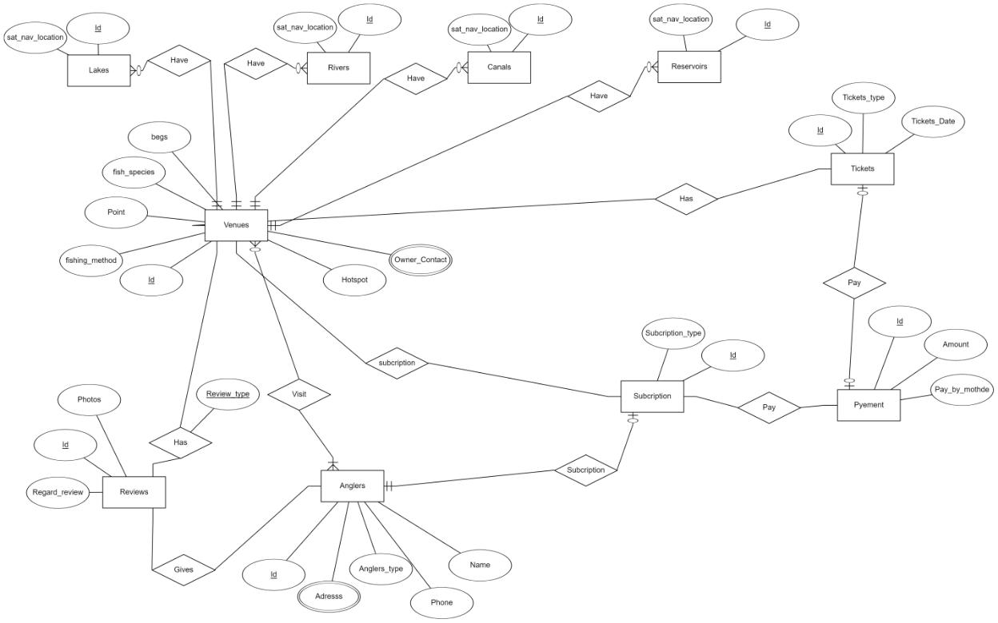

Figure 1: Entity Relationship Diagram (Database Star., [Accessed 31 March 2021].), (Microsoft , 1999)

Question 2

The un-normalized form:
5
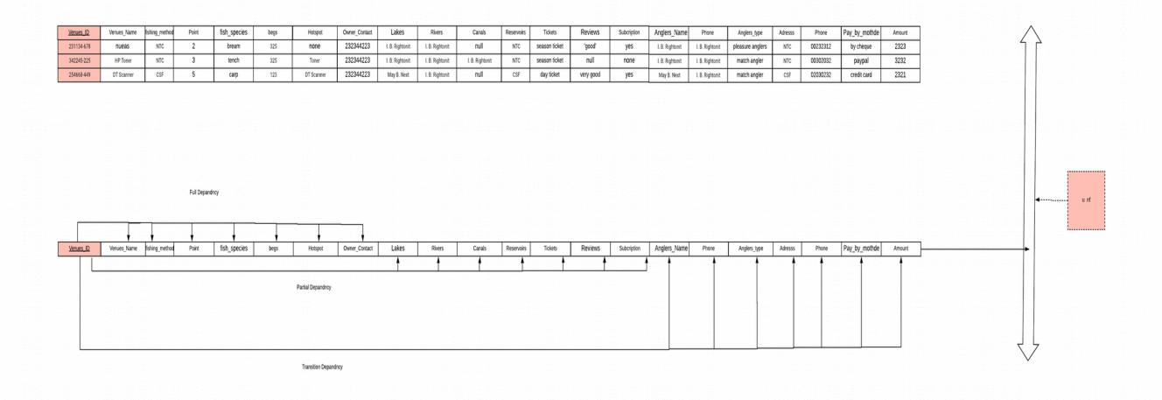

Figure 2: Un-normalized form (Semanticscholar.org., [Accessed 31 March 2021].)

1NF

The following are the guiding rules:
- Every respective table cell ought to comprise a distinct value
- Every record requires to be exceptional.
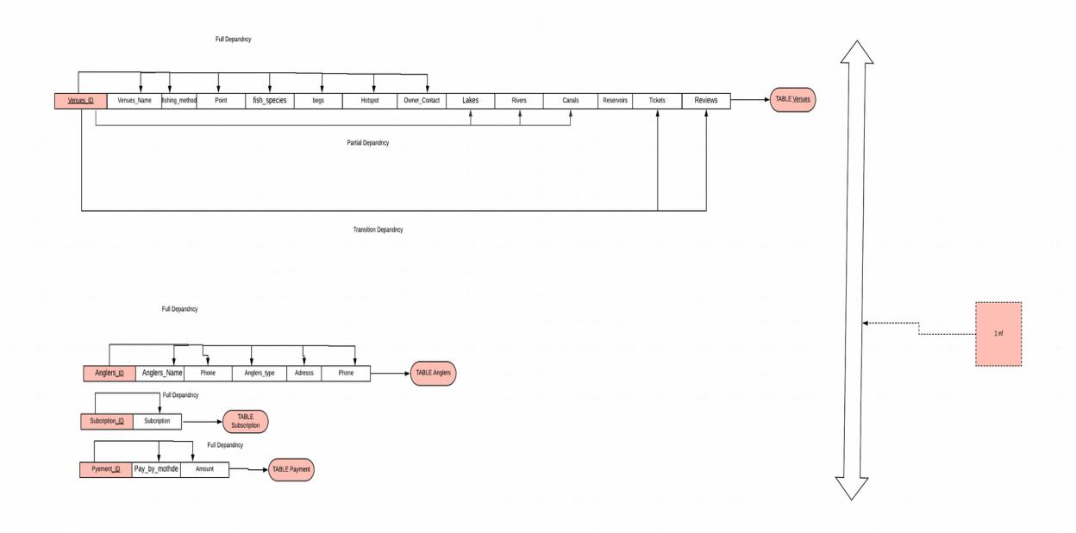

Figure 3: 1NF (Tutorialspoint.com. , [Accessed 31 March 2021].)

2NF

The following are the guiding rules:
- Should be in 1NF
- Particular Column be the primary key
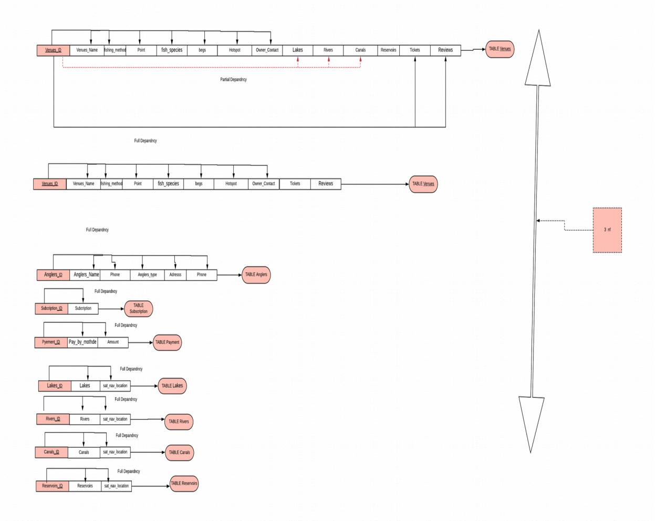

Figure 4: 2NF (1keydata.com., [Accessed 31 March 2021].)

3NF

The following are the guiding rules:
- Ought to be in 2NF
- Should not have transitive functional dependences
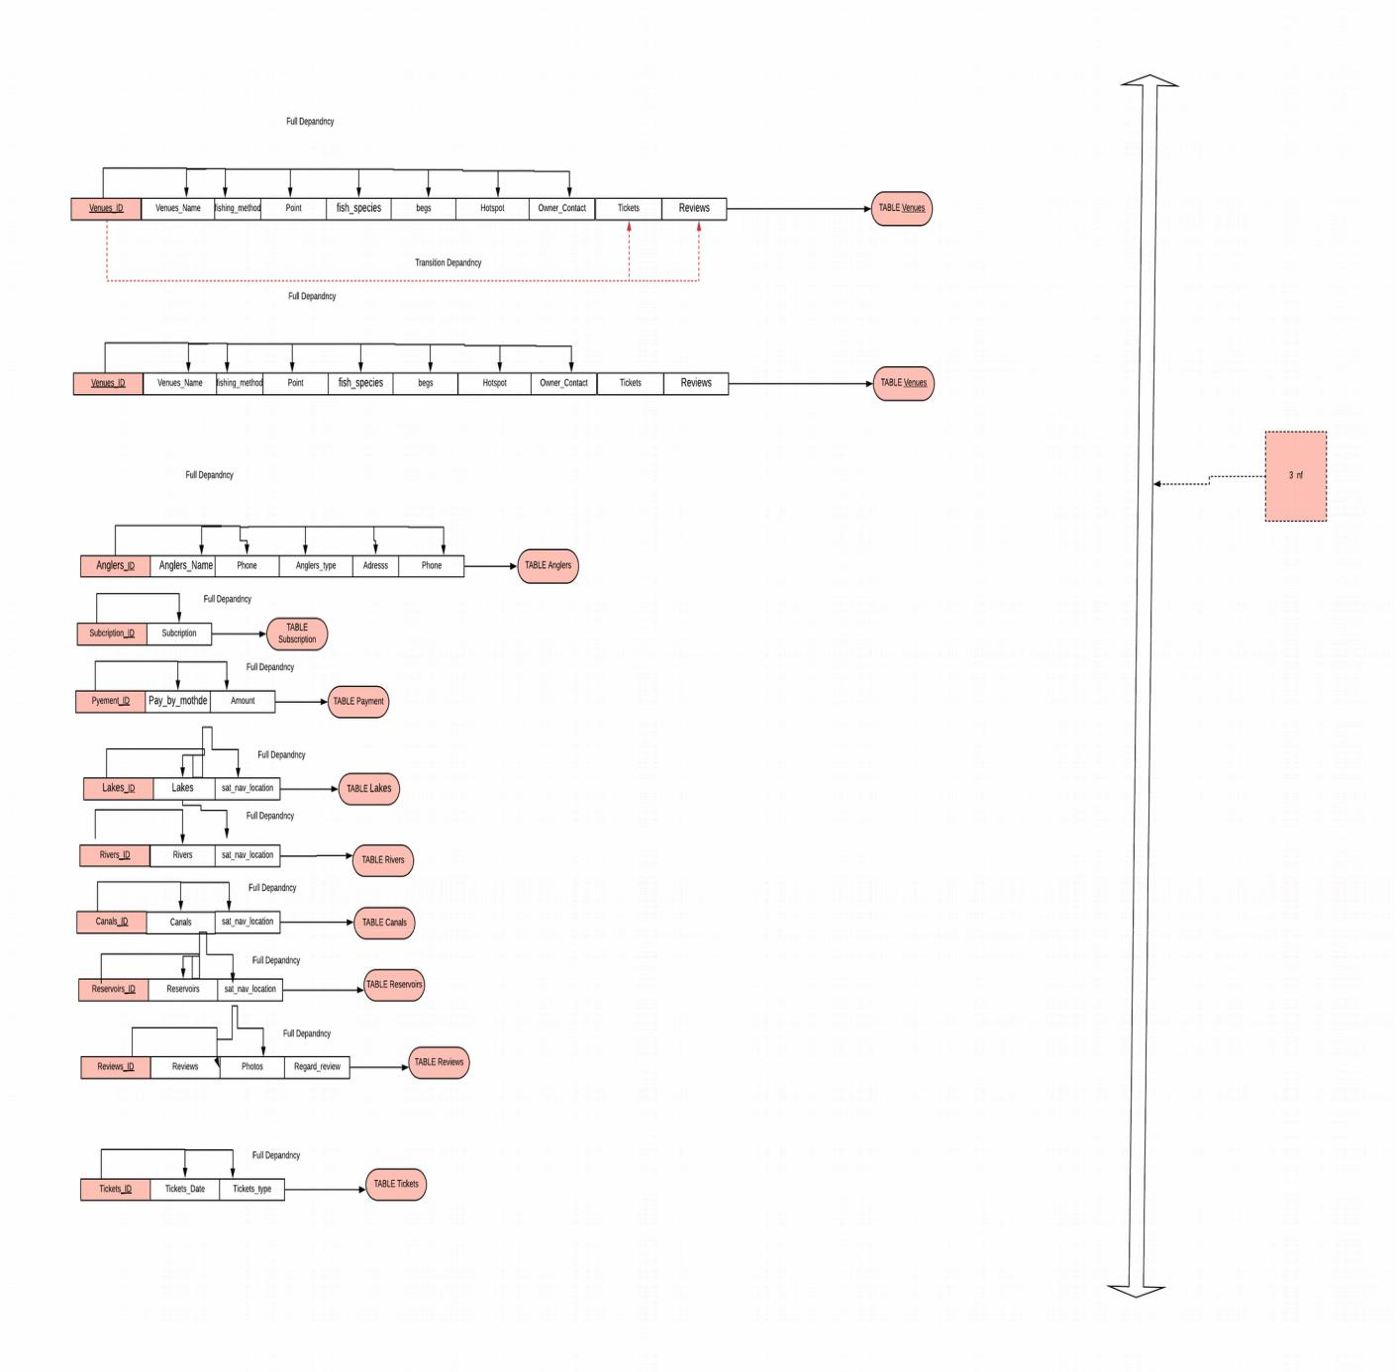

Figure 5:3NF (Tutorialspoint.com. , [Accessed 31 March 2021].)

Question 3
DBMS is a system of storing as well as recovering users' information whereas bearing in mind of applicable safety actions (Bhatia, A. and Bansal, V., 2015. ). It comprises of a collection of software that control the store. It also permits operators to construct their individual records as to their necessity providing the interface amongst data in addition to the system applications. (Coronel, C. and Morris, S., n.d. ) An example of a DBMS is a university database used to maintain records of student, course of study, and grades within the university setup. This database can be designed in five records as shown:
  - Student record for storing data of each and every student.
  - Course record for storing data comprising student course.
  - Section record for storing data of sections within the specific course.
  - Grade record for storing students grades for various sections.
  - Tutor record for storing information comprising of lecturers/professors.
A DBMS should have the following features:
  - Removes redundancy and providing security.
  - Supporting multiple views within records
  - Self-relating of a database program
  - Separation of data abstraction and programs
  - Permits entities with relations to make tables
  - Follows the ACID idea.
  - Supports multi-user setup which permits operators the ability of accessing and manipulating data in parallel.
The following are DBMS users: Database admins, application designers and developers and end users. There are four types DBMS such as: Hierarchical, Network, Relational and Object-Oriented database (Garcia-Molina, H., Ullman, J. and Widom, J., , 2000. ).

Hierarchical DBMS
Here, the database model is arranged in a tree structure and information stored in Hierarchical manner by use of parent-child relations. The parent might comprise of more than one children, on the other hand children only has one parent (Coronel, C. and Morris, S., n.d. ).

Network Model
The model permits every child to comprise several parents. This helps in addressing the need of modelling additional multifaceted relations such as orders with many-to-many relation. Here, entities are structured in a graph format that can be retrieved by means of numerous paths (Awad, E. and Gotterer, M., , 1992. ).

Relational Model
The model is centered on normalization of data into rows and columns of tables. The model is kept in static structures that are operated by use of SQL queries (Garcia-Molina, H., Ullman, J. and Widom, J., , 2000. ).

Object-Oriented Model
In this model information stored in form of objects with the construction of classes that shows data inside it. Database is defined as an assembly of objects that stores both member’s data values as well as actions (Coronel, C. and Morris, S., n.d. ).

I opted to use the relational model DBMS because of the following reasons: its simplicity of operations, structural individuality as it only fretful with data and not structures, easier to use because tables comprise of rows and columns that are simple and natural to understand, capability of data that makes it conceivable for SQL to evade complexity of database navigation, data independence where structures database can be altered without alteration of any application, scalability for enhancing database usability, finally it permitted for normalization of data into rows and columns of tables (Bhatia, A. and Bansal, V., 2015. ). The model

Question 4 a

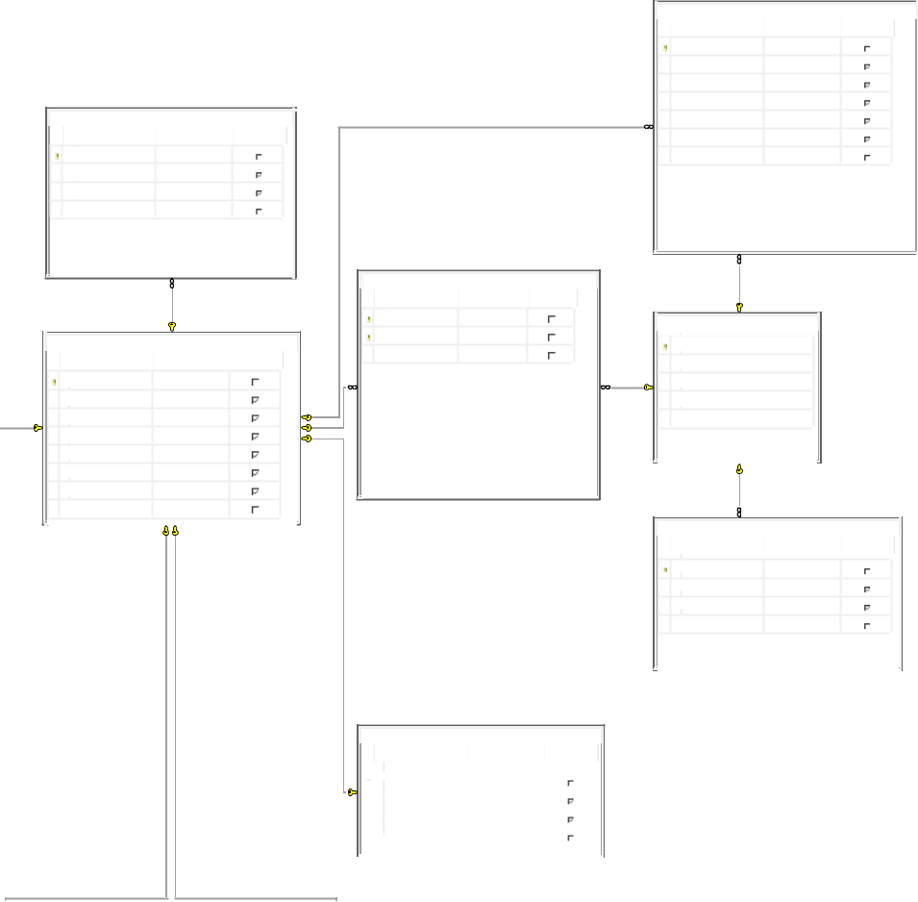

Canal

Column Name Data Type Allow Nulls

Canal_ID int

sat_nav_location nvarchar(50)

Venue_Id int

 |  |  |  |  | BrightVenueANdAngler
 |  |  |  |  | Column Name | Data Type | Allow Nulls
 |  |  |  |  | Venue_Id | int
Lakes |  |  | Venue |  | Angler_ID | int
Column Name | Data Type | Allow Nulls | Column Name | Data Type | Allow Nulls
Lakes_Id | int |  | Venue_Id | int
sat_nav_location | nvarchar(50) |  | fishing_method | nvarchar(50)
Venues_Id | int |  | Point | nvarchar(50)
 |  |  | fish_speciess | nvarchar(50)
 |  |  | begs | nvarchar(50)
 |  |  | Owners_Contact | nvarchar(50)
 |  |  | Hotspots | nvarchar(50)
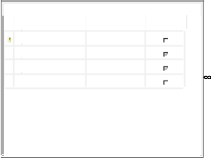

Reservoir

 |  | Column Name | Data Type | Allow Nulls
 |  | Reservoir_ID | int
 |  | sat_nav_location | nvarchar(50)
 |  | Venues_Id | int
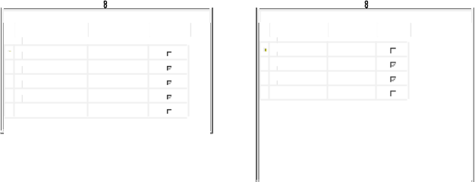

Ticket |  |  | River
Column Name | Data Type | Allow Nulls | Column Name | Data Type | Allow Nulls
Ticket_Id | int |  | River_Id | int
Ticket_type | nvarchar(50) |  | sat_nav_location | nvarchar(50)
Ticket_Date | nvarchar(50) |  | Venue_Id | int
Venue_Id | int

Snapshots:

Reviews

Column Name Data Type Allow Nulls

Reviews_Id int

Regard_reviews nvarchar(50)

Photo nvarchar(50)

Reviews_type nvarchar(50)

Angler_ID int

Venue_Id int

Angler

Anglers_ID

Anglers_type

Name

Phone

Adresss

Subcriptions

Column Name Data Type Allow Nulls

Subcriptions_ID int

Subcriptions_type nvarchar(50)

Angler_ID int
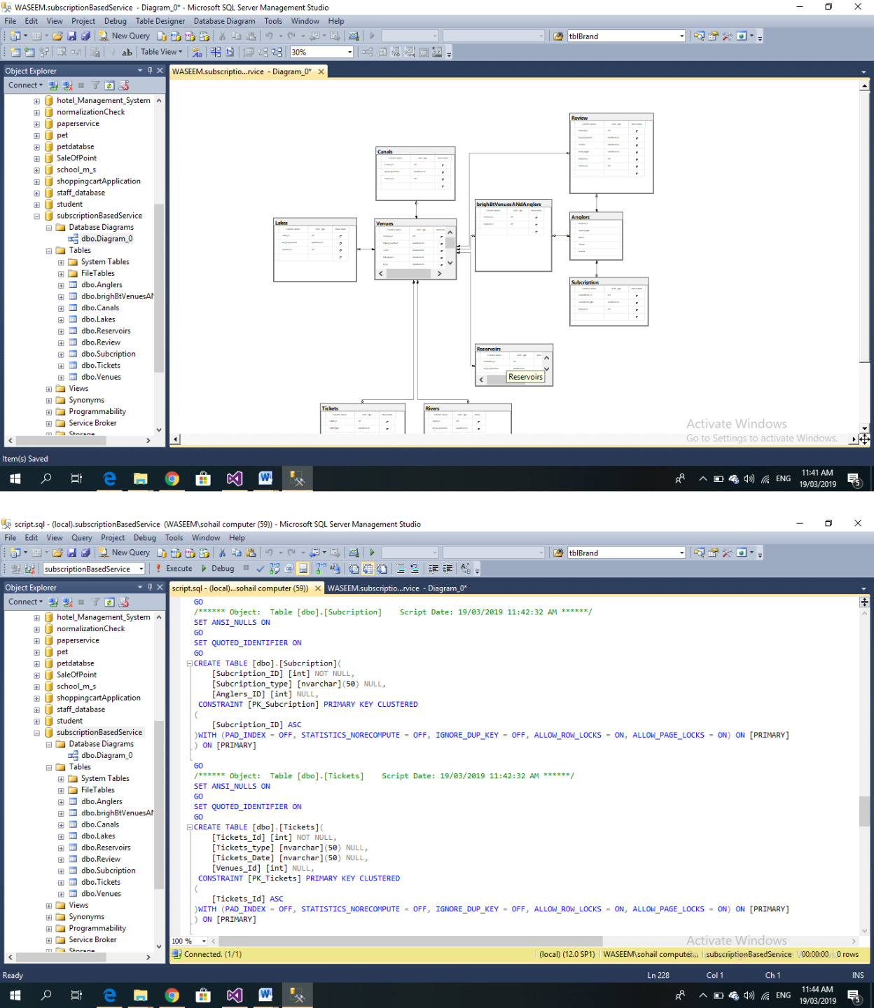

Question 4 b

Data in table

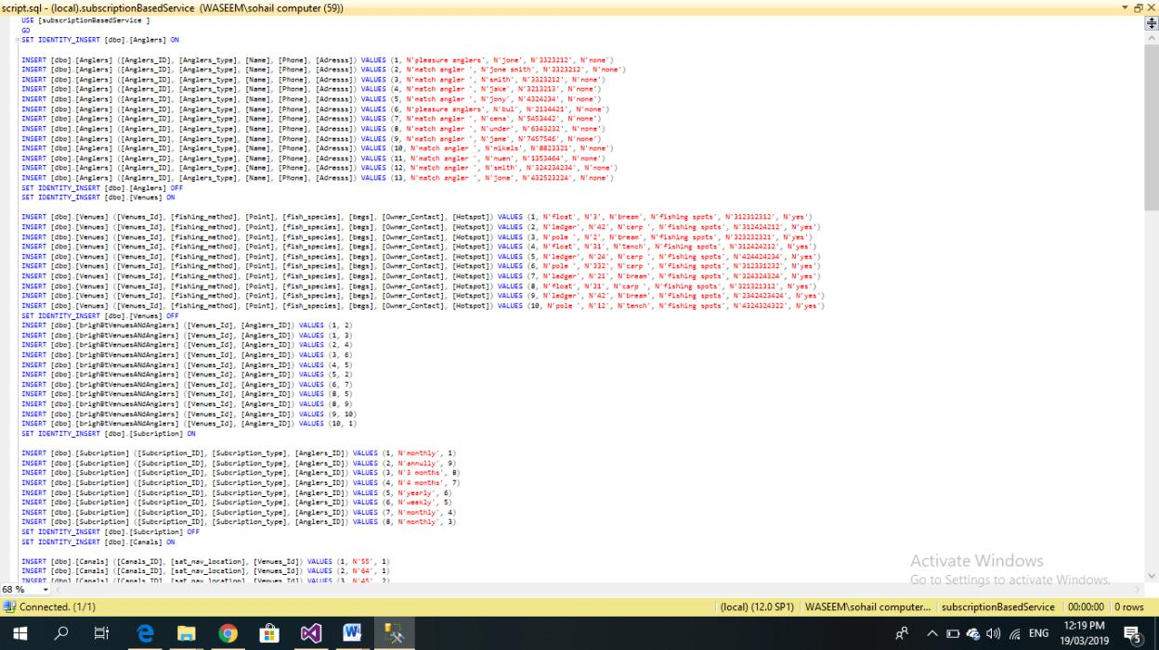

Question 4 c

SQL query with

Select * FROM Venue WHERE (Venue_Id =1)

Outcome snapshot:

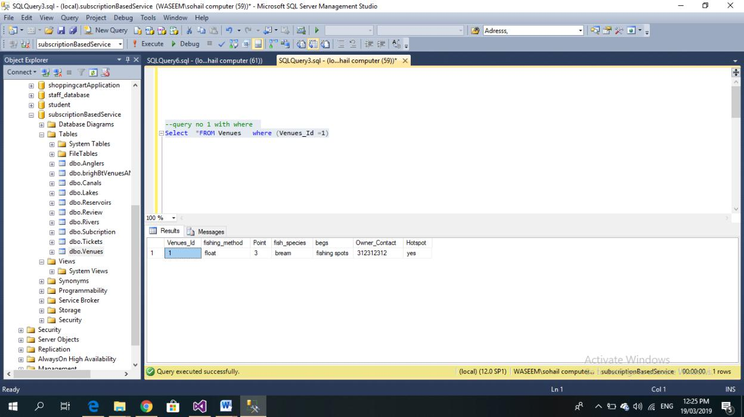

Order by SQL query

Select *FROM Venue order by Venue_Id

Snapshot outcome:
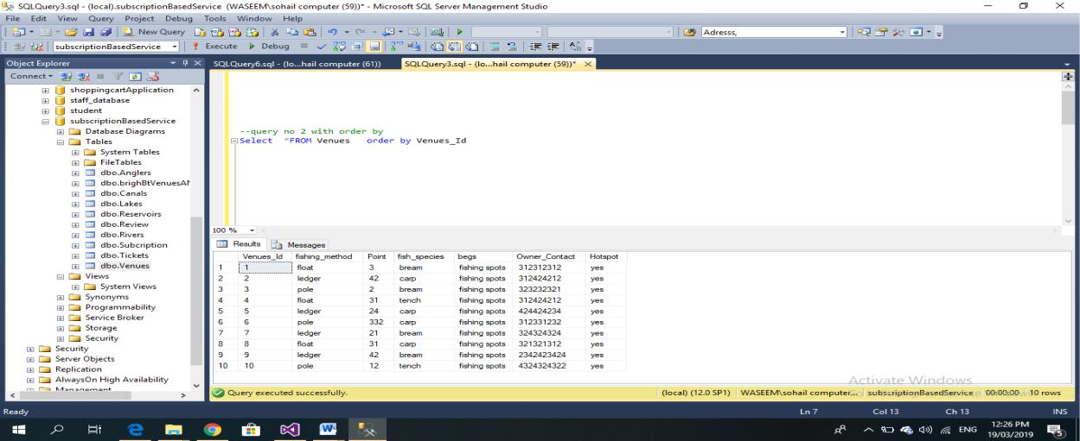

Inner JOIN SQL query
Select *FROM Venues as ven inner JOIN Canal as canals ON ven.Venue_Id = canals.Canal_ID

Snapshot Outcome:
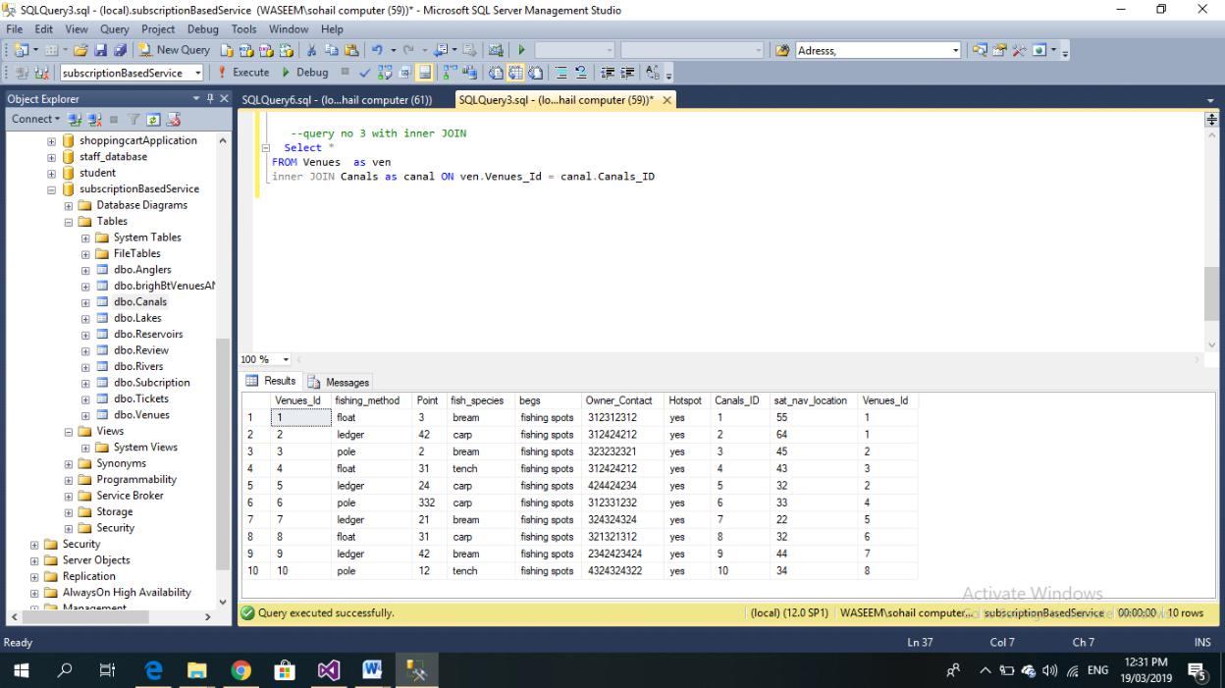

COUNT SQL query
SELECT COUNT (DISTINCT Venue_Id) as totalVenue FROM Venue

Snapshot outcome:
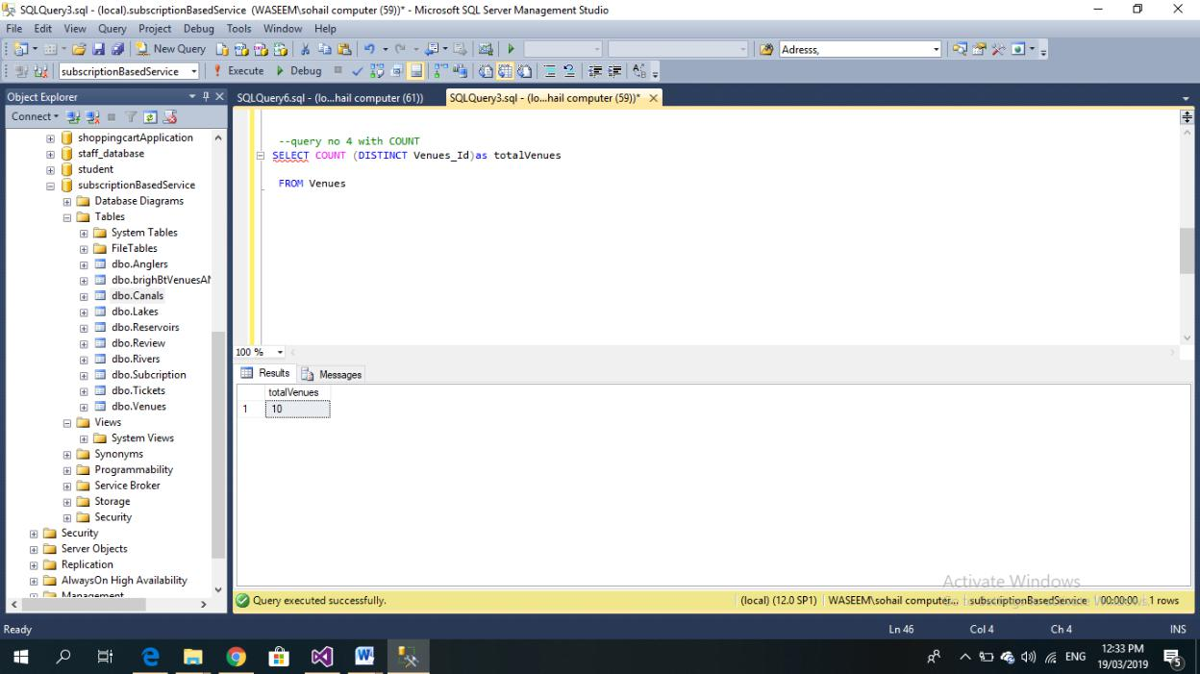

Inner JOIN SQL query

Select count(ven.beg) FROM Venue as ven inner JOIN Canal as canals ON ven.VenueId = canals.Canal_ID group by beg

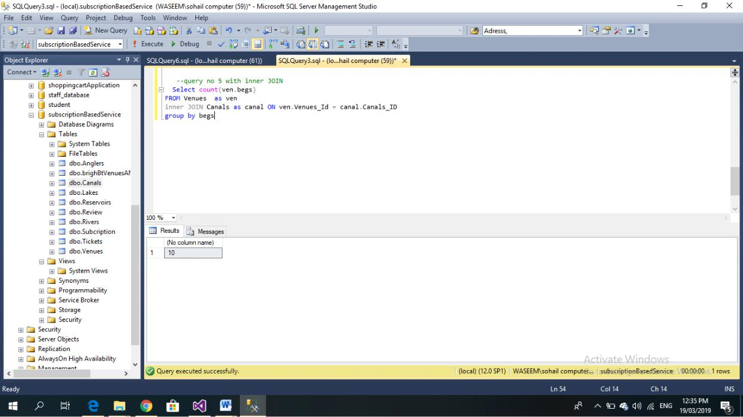
Snapshot outcome:

order by SQL query

Select *FROM Venue where (Venue_Id =4)

Snapshot outcome:
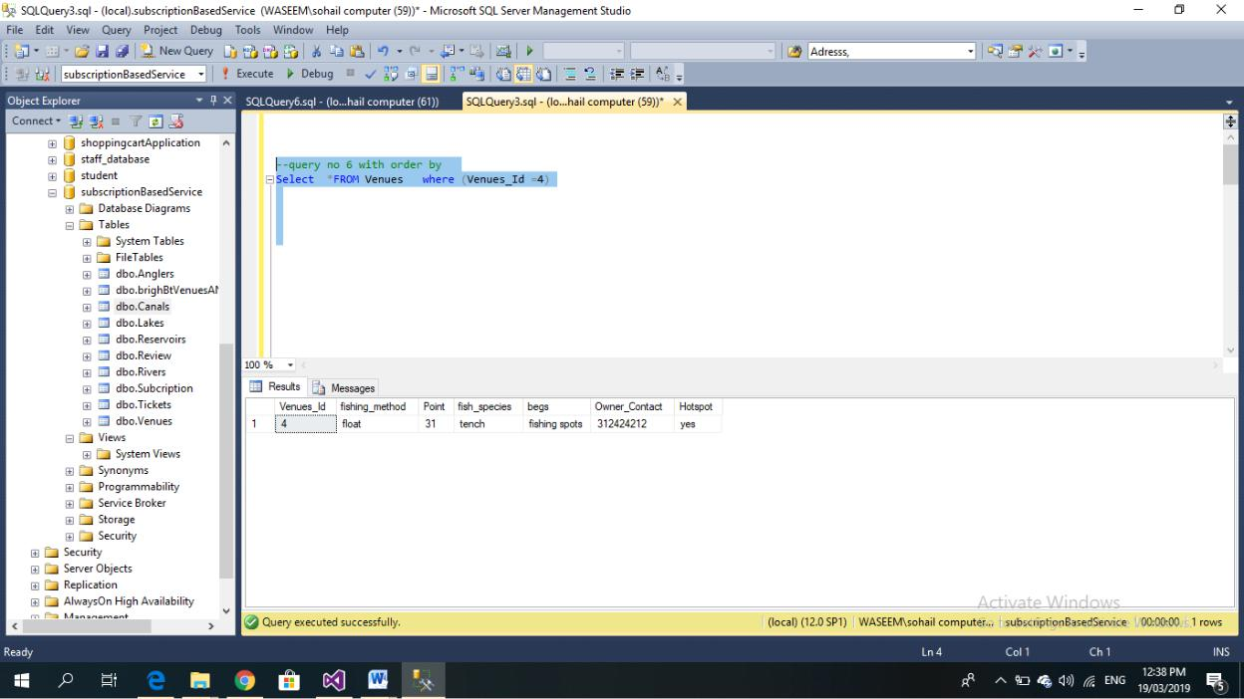

order by SQL query

Select *FROM Venue order by beg

Snapshots result:
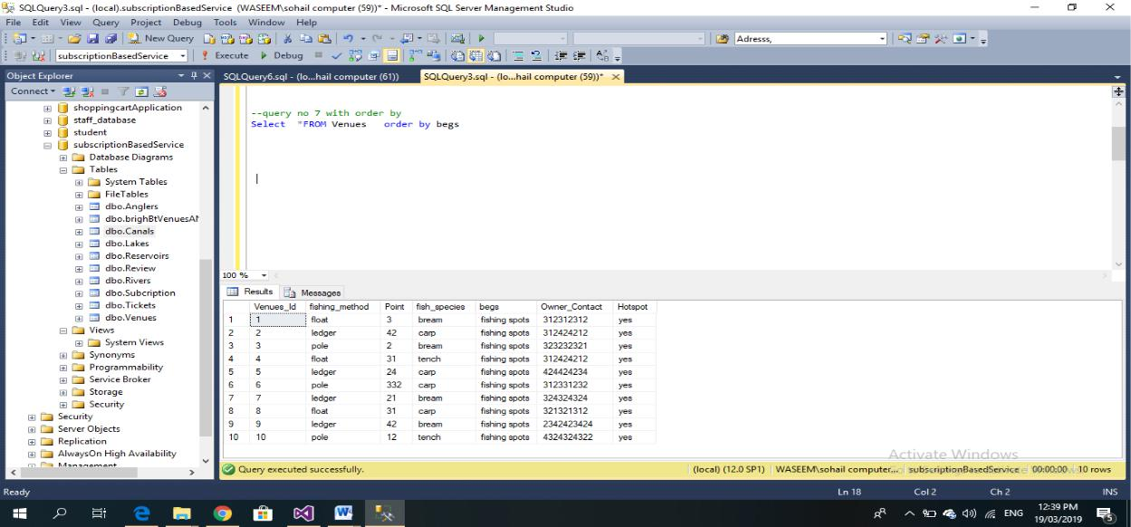

COUNT SQL query
SELECT COUNT (DISTINCT beg) as totalVenue FROM Venue

Snapshot outcome:
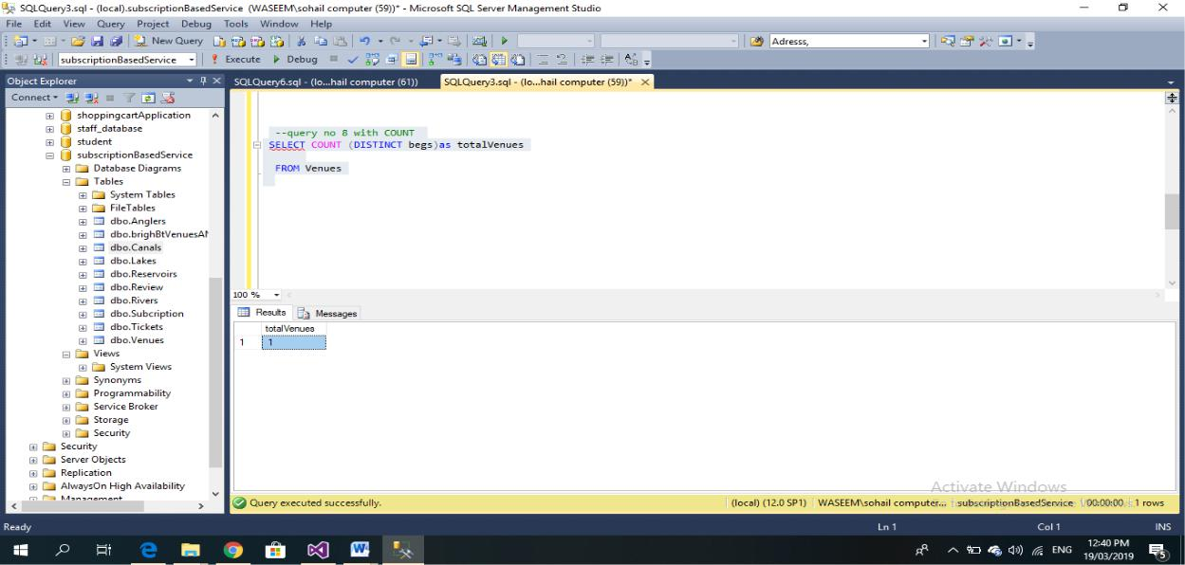

Inner JOIN query
Select count(ven.beg) FROM Venue as ven inner JOIN Lake as laks ON ven.Venue_Id = lak.Venue_Id group by beg

Snapshots outcome:
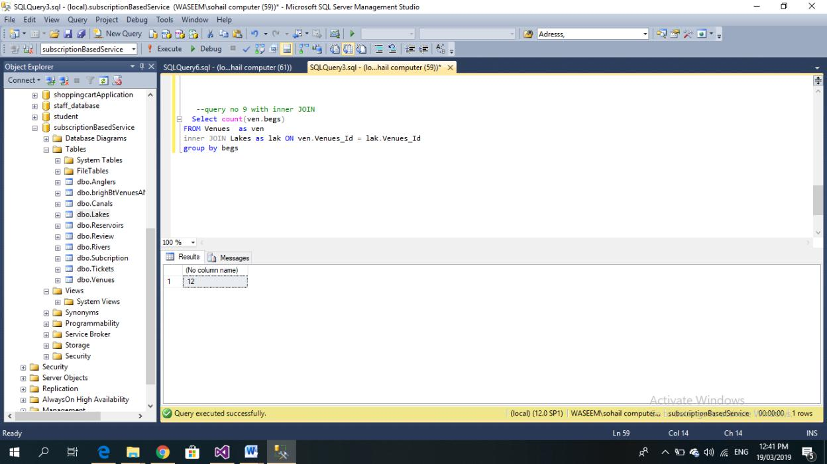

Select count(ven.beg) FROM Venue as ven inner JOIN Rivers as rev ON ven.Venue_Id = rev.Venue_Id group by beg

Snapshot outcome:
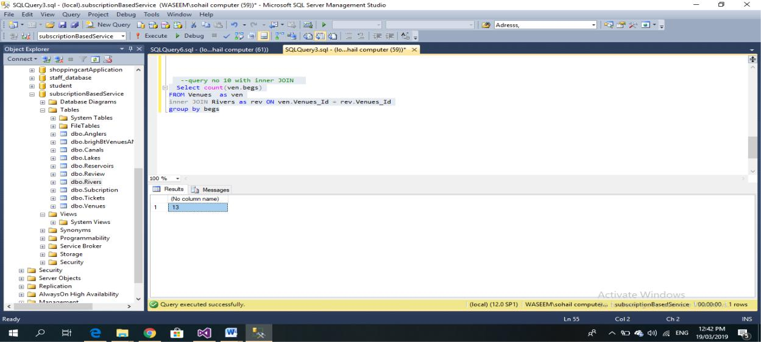

Question 5
For a better performance of the database, the following factors should be put to consideration as they influence database performance: Indexing, triggers, Stored procedures, workload, contention, optimization, resources and throughput as discussed below:
- Indexing. Index is an arrangement which grips fields sorted plus a pointer as of every record towards their conforming record of original table where there is storage of data. This creates columns quicker to query through creation of pointers to where data is located inside the database.
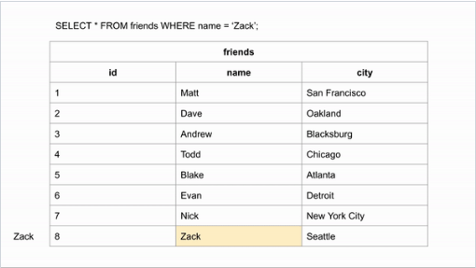
In case one wants to find “Zack” and data is alphabetical ordered, he/she jumps down halfway over the data to check if Zack originates earlier or later in the row, then the remaining rows can be halved to make the similar assessment.

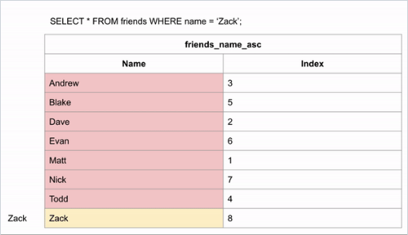
Indexing permits in creating sorted lists deprived of taking the creation entire new arranged tables, that might take up very much of storing space.
This shows how indexing maps back to original Friends table
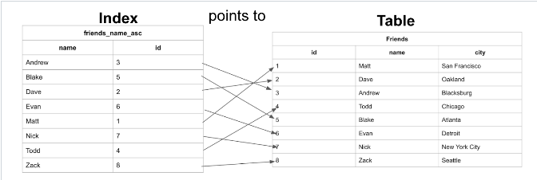
When indexing performed appropriately, helps to enhance query performance interval as well as increasing general performance of database through applying data structure which aids in keeping records structured in addition to making location of data easier. Essentially, indexing quickness up the process of data retrieval and making it more well-organized, thus saving effort and time.
- Triggers. database may consume more workload thus impacting performance. Dependent on what the trigger does, the structure of the table, and the load base on database impacts possibly will be invisible to end operators. Example
CREATE TABLE worker_0 AS
SELECT
x * worker_id as worker_id,
fNname,
lName,
email,
phoneNO,
hireDate,
'AD_VP' As career_id,
wage,
commissionPct,
director_Id,
unit_id
FROM
workers
CROSS JOIN (
SELECT level as x FROM dual CONNECT BY LEVEL <= 10000
) x
;
CREATE TABLE workers_1 AS SELECT * FROM workers _0;
CREATE TABLE workers _2 AS SELECT * FROM workers _0;

CREATE OR REPLACE TRIGGER hr.wage_check_1
BEFORE INSERT OR UPDATE OF wage, job_id ON hr. workers _1
FOR EACH ROW
WHEN (new.career_id <> 'AD_VP')
BEGIN
:new.wage := :new.wage + 1;
END;
/

CREATE TRIGGER hr.wage_check_2
BEFORE INSERT OR UPDATE OF wage, career_id ON hr. workers _2
FOR EACH ROW
BEGIN
IF (:new.career_id <> 'AD_VP') THEN
:new.wage := :new.wage + 1;
END IF;
END;
/

Then

set timing on;

update workers _0 set wage = wage + 2;

update workers _1 set wage = wage + 2;

update workers _2 set wage = wage + 2;

Outcome
1 070 000 rows updated.

Elapsed: 00:00:37.273

1 070 000 rows updated.

Elapsed: 00:00:37.232

1 070 000 rows updated.

Elapsed: 00:00:38.874

Test displays the insignificant variance amongst a table deprived of a trigger
- Stored procedure fix precisely what happens on the database, in the instance of tight security situations, firmly controller access is done on stored procedure relatively to tables. One can split the query in case the plan is sniffing. Thus Stored Procedures they may handed Database Tuning for performance reasons.
CREATE PROCEDURE AcquireBrandDesc
AS
BEGIN
SET NOCOUNT ON

SELECT B.BrandID,B.BrandName,BD.BrandDescription FROM
Brand B
INNER JOIN BrandDescription BD ON B.BrandID=BD.BrandID

END

References
1keydata.com. ([Accessed 31 March 2021].). Second Normal Form (2NF) - Database Normalization. [online] Available at: <https://www.1keydata.com/database-normalization/second-normal-form-2nf.php>.
Awad, E. and Gotterer, M., . (1992. ). Database management. . Danvers, Mass.: Boyd & Fraser Pub. Co.
Bhatia, A. and Bansal, V. ( 2015. ). Database Management System. . Oxford: Alpha Science Internat.
Coronel, C. and Morris, S., n.d. . (n.d.). Database systems.
Database Star. ([Accessed 31 March 2021].). A Guide to the Entity Relationship Diagram (ERD). In Available at: <https://www.databasestar.com/entity-relationship-diagram/> .
Garcia-Molina, H., Ullman, J. and Widom, J., . (2000. ). Database system implementation. . Upper Sadle River: Prentice Hall.
Microsoft . (1999). Microsoft SQL Server 7.0 database implementation training kit. Redmond: . Microsoft Press.
Semanticscholar.org. ( [Accessed 31 March 2021].). Unnormalized form | Semantic Scholar. [online] . Available at: <https://www.semanticscholar.org/topic/Unnormalized-form/6991923>.
Tutorialspoint.com. . ([Accessed 31 March 2021].). Database - First Normal Form (1NF) - Tutorialspoint. [online]. Available at: <https://www.tutorialspoint.com/sql/first-normal-form.htm> .
Tutorialspoint.com. . ([Accessed 31 March 2021].). Database - Third Normal Form (3NF) - Tutorialspoint. . [online] Available at: <https://www.tutorialspoint.com/sql/third-normal-form.htm> .

